**Add Two Numbers**

You are given two ****non-empty**** linked lists representing two non-negative integers. The digits are stored in ****reverse order****, and each of their nodes contains a single digit. Add the two numbers and return the sum as a linked list.

You may assume the two numbers do not contain any leading zero, except the number 0 itself.

****Example 1:****

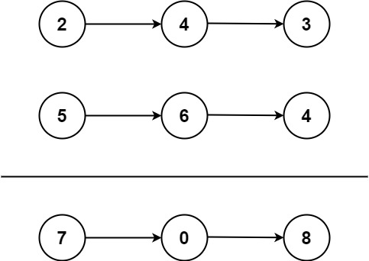

****Input:**** l1 = [2,4,3], l2 = [5,6,4]

****Output:**** [7,0,8]

****Explanation:**** 342 + 465 = 807.

****Example 2:****

****Input:**** l1 = [0], l2 = [0] ****Output:**** [0]

****Example 3:****

****Input:**** l1 = [9,9,9,9,9,9,9], l2 = [9,9,9,9] ****Output:**** [8,9,9,9,0,0,0,1]

****Constraints:****

* The number of nodes in each linked list is in the range [1, 100].
* 0 <= Node.val <= 9
* It is guaranteed that the list represents a number that does not have leading zeros.

**Solutions:**

/**

* Definition for singly-linked list.

* public class ListNode {

* int val;

* ListNode next;

* ListNode() {}

* ListNode(int val) { this.val = val; }

* ListNode(int val, ListNode next) { this.val = val; this.next = next; }

* }

*/

class Solution {

public ListNode addTwoNumbers(ListNode l1, ListNode l2) {

ListNode dummyHead = new ListNode(0);

ListNode p = l1, q = l2, curr = dummyHead;

int carry = 0;

while (p != null || q != null) {

int x = (p != null) ? p.val : 0;

int y = (q != null) ? q.val : 0;

int sum = carry + x + y;

carry = sum / 10;

curr.next = new ListNode(sum % 10);

curr = curr.next;

if (p != null) p = p.next;

if (q != null) q = q.next;

}

if (carry > 0) {

curr.next = new ListNode(carry);

}

return dummyHead.next;

}

}